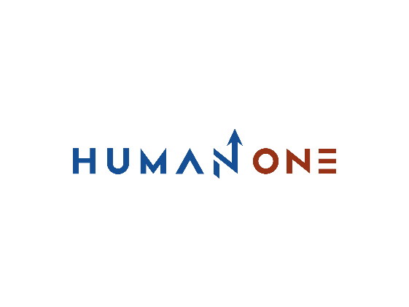

Services

Expertise

**EN**

**FR**

Get in touch

Company

Who We are

**Who We Are**



HumanOne is a company that specializes in consulting, software development, and digitalization by combining the best consultants with a total commitment to meeting the unique expectations of each of its clients.

HumanOne favors a horizontal, agile, flexible and transparent organization. We deploy all of our energies, which makes us a reliable and proven software engineering provider.

With HumanOne, you choose to :

* To position you above all on the accompaniment of strategic reflections to help you make the right choices and create the conditions for the success of your projects
* A team of consultants who are experts in their field to bring you the added value required by your challenges.
* A foresight structure designed to cross experiences, analyze trends to bring you new angles of analysis, and finally allow you to anticipate changes.

Get to know us >

**Get to know HumanOne**

Find out what we stand for and what drives us in our day-by-day path to technological excellence. Look at our people who apply their expert knowledge and personal dedication to help businesses stand out and set the industry standard. Learn how we can translate your boldest ideas into the comprehensive solution of real-life challenges.

Play video

**Our Promise…**

We bring to our clients the best engineering talent, a deep knowledge of each sector in which we operate, and an unwavering dedication to satisfying each of our clients' requests

No matter how complex your project is, we deploy all of our resources to deliver the most technological and efficient solutions and softwares. We offer digital workflows that create exceptional experiences and maximize productivity.

Our added value is manifested in the combination of solid and restricted human relationships with the upmost technology in our multiple missions.

We attach great importance to the ethics and values of our profession such as integrity, confidentiality, transparency and honesty of our proposals.

**Our approach**

## Project setup

As soon as HumanOne receives your project, we give you instant access to all of our technological skills supported by our ready-to-use IT infrastructure and our most proven software engineering processes.

## 

## What's new

Article 8

Article 7

Article 6

Article 5

Article 4

Article 3

Article 2

Article 1

**View all >**



